Salem County 4-H T-Shirts & Hoodies 2022
Fundraiser for Salem County Leaders Association
Delivery will be mid-December, just in time for Christmas!

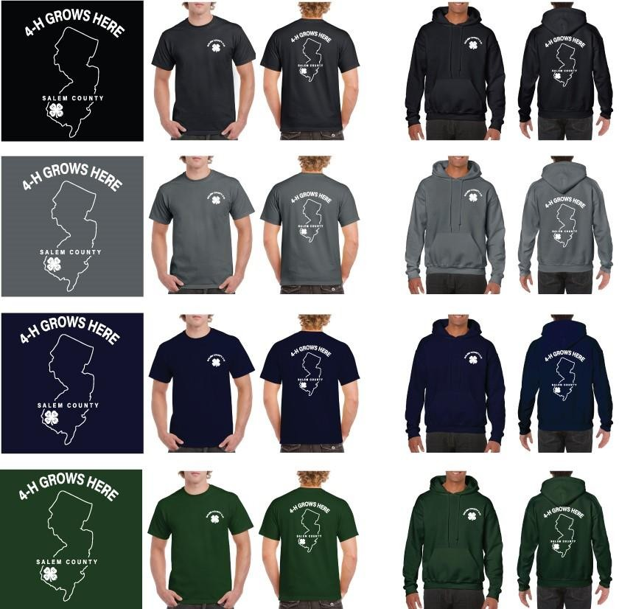
OFFERING:

Style: T-shirt ($15) or Hoodie Sweatshirt ($20)
Color Choices: Black, Gray, Navy Blue, Forest Green
Youth Sizes: Youth Extra Small (YXS) to Youth Extra Large (YXL)
Adult Sizes: XS-4XL (+$2 for 2X, 3X, and 4X)

PLEASE be sure to indicate Youth with a Y in
front of the size!

Name:

Phone Number: Email:

Shirt or Hoodie | Color | Size | Quantity
Total # of items: Amount Included:
Cash and personal check accepted. Please make out check to Salem County 4-H Leaders Association.
Order form due to Tricia Bohren by Thursday, November 17
Mail to: Tricia Bohren 224 Fir Ave, Richland NJ 08350
Or you can drop them off at the 4-H Office
Call with questions: 856-628-6460

